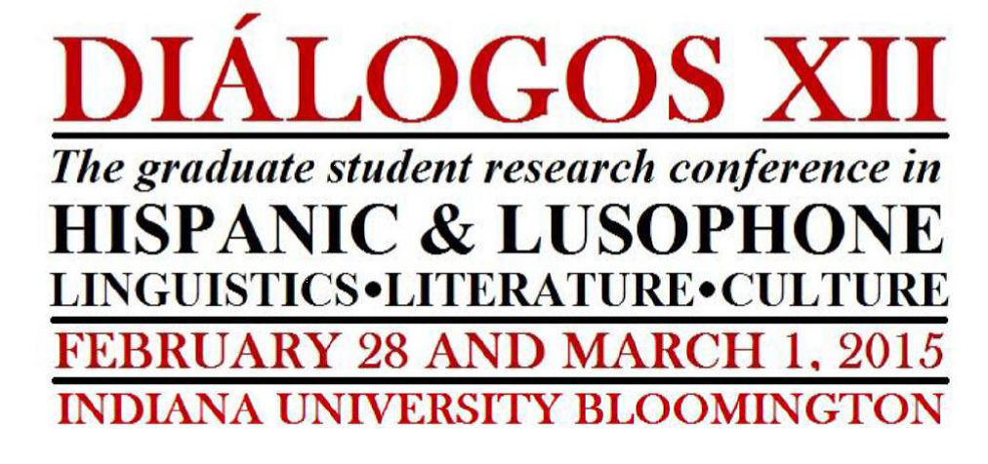
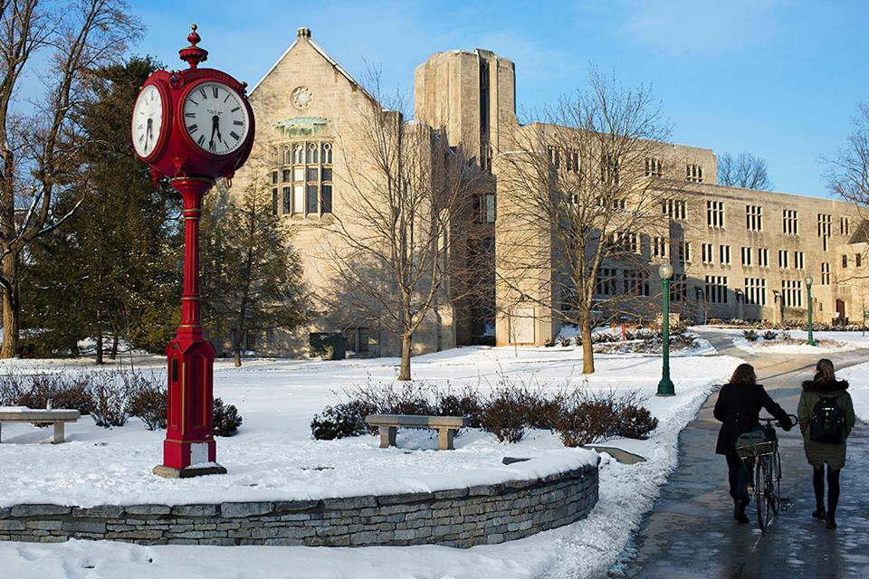
Cover photo courtesy of Indiana University

!
Organized by
The Graduate Student Advisory Committee of Indiana University’s Department of Spanish and Portuguese

¡BIENVENIDOS!
BEM-VINDOS!
WELCOME!

The Graduate Student Advisory Committee welcomes you to its Twelfth Annual Graduate Student Research Conference. The Diálogos Conference strives to reflect the diversity of the field in all areas of Spanish Peninsular, Spanish-American, and Lusophone Linguistics, Literature, and Culture. For more than a decade, the annual Graduate Student Conference of the Department of Spanish and Portuguese at Indiana University has provided a venue for graduate-level scholars from around the globe to share their research with others in their field. Participants benefit from engaging with a broad array of scholars in a collegial atmosphere at one of the region’s largest and most respected departments of Spanish and Portuguese. We are excited to share with you our first-ever two-day extension of the conference and look forward to the future growth and development of this project. We thank you for being a part of the Diálogos XII Graduate Student Research Conference and hope you enjoy, learn, and connect with other scholars as we share our research and interests in our fields.
GSAC 2014-2015

Mark Fitzsimmons

Moses Fritz

Matt Johnson

Cynthia Martinez

Ian Michalski

Angel Milla Muñoz

Alysa Schroff

-2-

KEYNOTE ADDRESS
Professor J. Ignacio Hualde
Department of Spanish and Portuguese
University of Illinois at Urbana-Champaign

“Language contact and sound change

in Judeo-Spanish”

9:00-10:00, IMU Dogwood Room
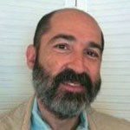

José Ignacio Hualde is originally from Navarre, Spain. After completing his studies in Spain, he arrived in the United States where he pursued his postgraduate studies, earning two Master’s degrees and a PhD in the field of Linguistics at the University of Southern California. Once he graduated, he joined the faculty of the Department of Spanish, Italian and Portuguese, as well as the Department of Linguistics at the University of Illinois at Urbana-Champaign. Throughout his very prolific career, he has become one of the foremost researchers and theorists in the study of phonology and phonetics, as well as language contact, prosody, phonological processes and linguistic policies in the Basque Country (Spain). Prof. Hualde has published over 140 articles and he is the author and co-author of many influential books, such as Basque Phonology (1991) or Los Sonidos del Español (2014). Among his many publications, Prof. Hualde has explored a wide variety of topics including descriptive grammars of Peninsular languages such as Catalan (1992), descriptions of the phonological systems of Basque (1992, 1994, 1997), or Spanish (2005, 2014). He is currently working with Judeo-Spanish or Ladino from a historical perspective, focusing on particular phonological processes. All in all, Prof. Hualde’s research has contributed to broaden our knowledge, not only in the field of Hispanic Linguistics but also, of the linguistic aspects of some other languages spoken in the Iberian Peninsula, such as Basque and Catalan.

KEYNOTE ADDRESS
Professor Steven Marsh
Department of Hispanic and Italian Studies
University of Illinois at Chicago

“The Ex- of Experimental Cinema: Filmmaking in Late Francoist Spain”

4:15-5:15, IMU Dogwood Room

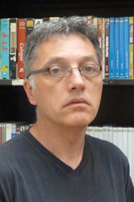
Professor Steven Marsh received his PhD in Hispanic Cultural Studies from the University of London in 2002, and is currently Associate Professor of Spanish film and Cultural Studies in the Department of Hispanic & Italian Studies at the University of Illinois at Chicago. His interests include Film Studies, Cultural Theory, Marxism, Urban Studies, and Spanish Politics. He is the author of Popular Spanish Film Under Franco: Comedy and the Weakening of the State (Palgrave Macmillan, 2005), which develops an approach to cinematic comedies produced during the Franco regime that pushes beyond the common conception that popular film of the period functioned as mere statist propaganda. He is also the co-editor of Gender and Spanish Cinema (Oxford, 2004), and has published widely in journals and book collections in the US, UK, Chile and Spain. Recently, Marsh has served as invited editor of the forthcoming Journal of Spanish Cultural Studies special dossier on Spanish film and spectrality (2015), and published articles in Discourse and Hispanic Review. He is currently finalizing a new monograph, provisionally titled Spanish Film, a Counter-History: Cosmopolitanism, Experimentation, Militancy. He is a member of the editorial collective of the Journal of Spanish Cultural Studies, and an editorial committee member (and founding editor) of the journal Studies in Hispanic Cinemas.

Presenters

Literature & Linguistics

Boyd, Beth………………… bethboyd@indiana.edu
Cole, Christie …………………. colece@indiana.edu
Filimonova, Valentyna ………… valefili@indiana.edu
Fiuza, Felipe …………………… ffiuza@purdue.edu
Fritz, Moses..................................... rkfritz@indiana.edu
Fritz, Valeriya ………….. vfedonki@indiana.edu
Galavitz, Rowena …………….. rgalavit@indiana.edu
Garrett, Jordan……………….. garretjm@indiana.edu
Hoff, Mark …………………… hoff.96@osu.edu
Johnson, Matt...……………. msjohns@indiana.edu
Knight, Justin………………… justknig@indiana.edu
López Pajares, Álvaro……… alvalope@indiana.edu
Markle, Jackie………………. jmmarkle@indiana.edu
Medrano, José Manuel ………… jmedr003@ucr.edu
Merino, Laura………………. lmerino@indiana.edu
Michalski, Ian ……………… imichals@indiana.edu
Núñez García, Brisa …………… brisang@unm.edu
Pecorelli, Joe ……………….... jpecorel@indiana.edu
Pisabarro Sarrió, Silvia …………. sip23@pitt.edu
Rivera, Óscar ………………….... orive002@ucr.edu
Robinson, Ellen Ryan………… ellrobin@indiana.edu
Salzano, Olivia……………... ohollowa@indiana.edu
Santander Serrano, Jorge…… jorsanta@indiana.edu
Taylor, Jenna……………….. taylor57@indiana.edu
Teran, Virginia …………………… vit14@pitt.edu
Whitten, AJ……………………. jwhitten1@gsu.edu

Schedule of Events

Indiana Memorial Union • Tree Suites Bloomington, IN

Registration & Breakfast 8:00am • Redbud Room

Opening Remarks
Keynote Address by Professor Jose Ignacio Hualde
“Language Contact and Change in Judeo Spanish”
9:00-10:00am • Dogwood Room

Session 1
Morning Sessions (10:15am-1:30pm)

10:15-11:45am • Sassafrass, Persimmon
Session 2
12:00-1:30pm • Sassafrass, Persimmon

Lunch Break
1:30-2:30pm

Session 3
Afternoon Sessions (2:30-4:00pm)

2:30-4:00pm • Sassafrass, Persimmon
SATURDAY,
FEBRUARY 28, 2015

Closing Keynote Address by Professor Steven Marsh
“The Ex- of Experimental Cinema: Filmmaking in Late Francoist Spain”
4:15-5:15pm • Dogwood Room

Schedule of Events

Indiana Memorial Union • Tree Suites

Bloomington, IN

Registration & Breakfast 8:00am • Redbud Room

Session 1
Morning Sessions (9:00am-11:45am)

9:00-10:30am • Sassafrass Room
Session 2
10:45-11:45am • Sassafrass Room

Lunch Break
11:45am-1:00pm

Session 3
Afternoon Sessions (1:15-4:00pm)

1:15-2:15pm • Sassafrass Room
SUNDAY,
MARCH 1, 2015

Session 4
2:30-4:00pm • Sassafrass Room

End of the conference

SATURDAY,
FEBRUARY 28, 2015

DIÁLOGOS XII

8:30am • Registration & Breakfast

Schedule of presentations
Indiana Memorial Union • Tree Suites Bloomington, IN
IMU Redbud Room

9:00am-10:00am • Opening Keynote Address, Professor José Ignacio Hualde
IMU Dogwood Room

Morning Sessions (10:15-2:30pm)

Session 1: 10:15-11:45

Literature I • Sassafrass Room
Moderator: Christie Cole

Cognitive Approaches to 17th-Century Literature
“Embodied Carnivalization: Cognition in Don Quixote I (15– 16)”
Felipe Fiuza, Purdue University
"The Cognitive Conceit: Blending and Baltasar Gracián's Agudeza y arte de ingenio"
Robert Fritz, Indiana University
“Sensory Perception, Cognitive Dissonance, and Narrative in the Cave of Montesinos of Cervantes’ Don Quixote”
Beth Boyd, Indiana University

Linguistics I • Persimmon Room
Moderator: Silvina Bongiovanni

Spanish Morphology and Syntax variation in the Southern Cone
“Sociolinguistic variation of past time expression in the urban dialect of Tucumán (UTS)”
Virginia Teran, University of Pittsburgh
“Extended accusative a-marking in Argentine Spanish: Awareness, attitudes, and acceptability”
Mark Hoff, The Ohio State University

Session 2: 12:00-1:30pm

Literature II • Sassafrass Room
Moderator: Moses Fritz

Epic Visions: The Lusiads of Luís Vaz de Camões
“Nuvens camonianas: as impregnadas e as divinas”
Joe Pecorelli, Indiana University
“Legitimizations of the Modern Age in Hans Blumenberg and Luís de Camões”
Matthew Johnson, Indiana University
“Desire Dis-covered: Nakedness and Clothing in The Lusiads by Luís Vaz de Camões”
Olivia Salzano, Indiana University

Interdisciplinary Panel and Discussion • Persimmon Room
Moderator: Jordan Garrett

Crossing Borders: Interdisciplinary approaches to Hispanic literature
“Exile and Border Identity: Linguistic Evidence from Leísmo Use in Works of Cecilia G. de Guilarte”
Valentyna Filimonova and Valeria Fritz, Indiana University
“Gringo vs. Jíbaro: US Food Imperialism, Puerto Rico, and the ‘Better Diet’”
Ian Michalski, Indiana University
Open Forum Discussion with Panelists and Audience on the value of
interdisciplinary research

Lunch Break
1:30-2:30pm

Afternoon Sessions (2:30-5:00pm)
Session 3: 2:30pm-4:00pm

Literature III • Sassafrass Room
Moderator: Alysa Schroff

Protestas contra el poder en la literatura hispana
“‘Mejor morir que vivir atada y presa’: La dialéctica de género en La plaza del Diamante.”
Jackie Markle, Indiana University
“Bonifacia como representación de la doble expiación: por ser indígena y mujer en la novela peruana La casa verde de Mario Vargas Llosa”
Brisa Núñez García, University of New Mexico

Linguistics II • Persimmon Room
Moderator: Sara Zahler

Language Variation, Contact, and Change: Lusophone and Hispanic Perspectives
“To have and to hold: Gradience and diachronic change in Portuguese auxiliary selection in perfect tense morphology”
Jordan Garrett, Indiana University
“Intervocalic /d/ lenition in Barranquenho: An analysis of the phonetic realizations of a variable segment in a mixed language”
Jenna Taylor, Indiana University
“Tú/usted in the Spanish of Catalonia: Data on the Speech of University Students of Tarragona”
Silvia Pisabarro Sarrió, University of Pittsburgh

4:15pm-5:15pm • Closing Keynote Address by Professor Steven Marsh Dogwood Room

Schedule of presentations
Indiana Memorial Union • Tree Suites Bloomington, IN

DIÁLOGOS XII
SUNDAY, MARCH 1, 2015

Morning Sessions (9:00-11:45am)

Session 1: 9:00-10:30am

Literature IV • Sassafrass Room
Moderator: Mark Fitzsimmons

Aproximaciones cinematográficas
“De Cierta Manera: Estrategias realista que exponen la realidad cubana”
AJ Whiten, Georgia State University
“Fútbol no es fútbol: La ideología del deporte rey en el cine franquista”
Álvaro López Pajares, Indiana University
“Reconciliación: Un abrazo entre el homosexual y el régimen”
José Manuel Medrano, University of California, Riverside

Session 2: 10:45am-11:45am

Literature V • Sassafrass Room
Moderator: Eric Carbajal

Global Perspectives on the Early Modern Hispanic World
“El criollo del mundo americano”
Óscar Rivera, University of California Riverside
“Shifting Subjects: Jacques Lacan and John of the Cross”
Rowena Galavitz, Indiana University

Lunch 11:45am-1:00pm

Afternoon Sessions (1:15-4:00pm)

Session 3: 1:15-2:15pm

Literature VI • Sassafrass Room
Moderator: Matt Johnson

Ciencia, maravilla, e imperio en El Quijote
“Mechanisms of Wonder: Marvels in Don Quijote Part II”
Christie Cole, Indiana University
“Las estrellas narrativizan: Aproximaciones a las ciencias adivinatorias en El Quijote y El Persiles”
Jorge Santander Serrano, Indiana University

Session 4: 2:30-4:00

Literature VII • Sassafrass Room
Moderator: Cristobal Garza

Identity and Nation in 19th Century Peninsular and Latin American Literature
“Jose de Alencar: Project for a nation”
Laura Merino, Indiana University
“The Medieval-Romantic lenda Constructs the Nation: The Legends of Herculano and Bécquer”
Ellen Ryan Robinson, Indiana University
“The Part of the Multitude: A Reconsideration of the Politics of Palma’s Tradiciones peruanas”
Justin Knight, Indiana University
Volunteers & Moderators

Silvina Bongiovanni
Beth Boyd
Eric Carbajal
Vanessa Elias
Jordan Garrett
Cristóbal Garza-González

GSAC greatly appreciates the help and support of all our volunteers. Thank you for helping to make the 12th Annual Diálogos Conference a success!

Álvaro López Pajares
Laura Merino
Gloria Navajas Sánchez
Daryl Spurlock
Sara Zahler

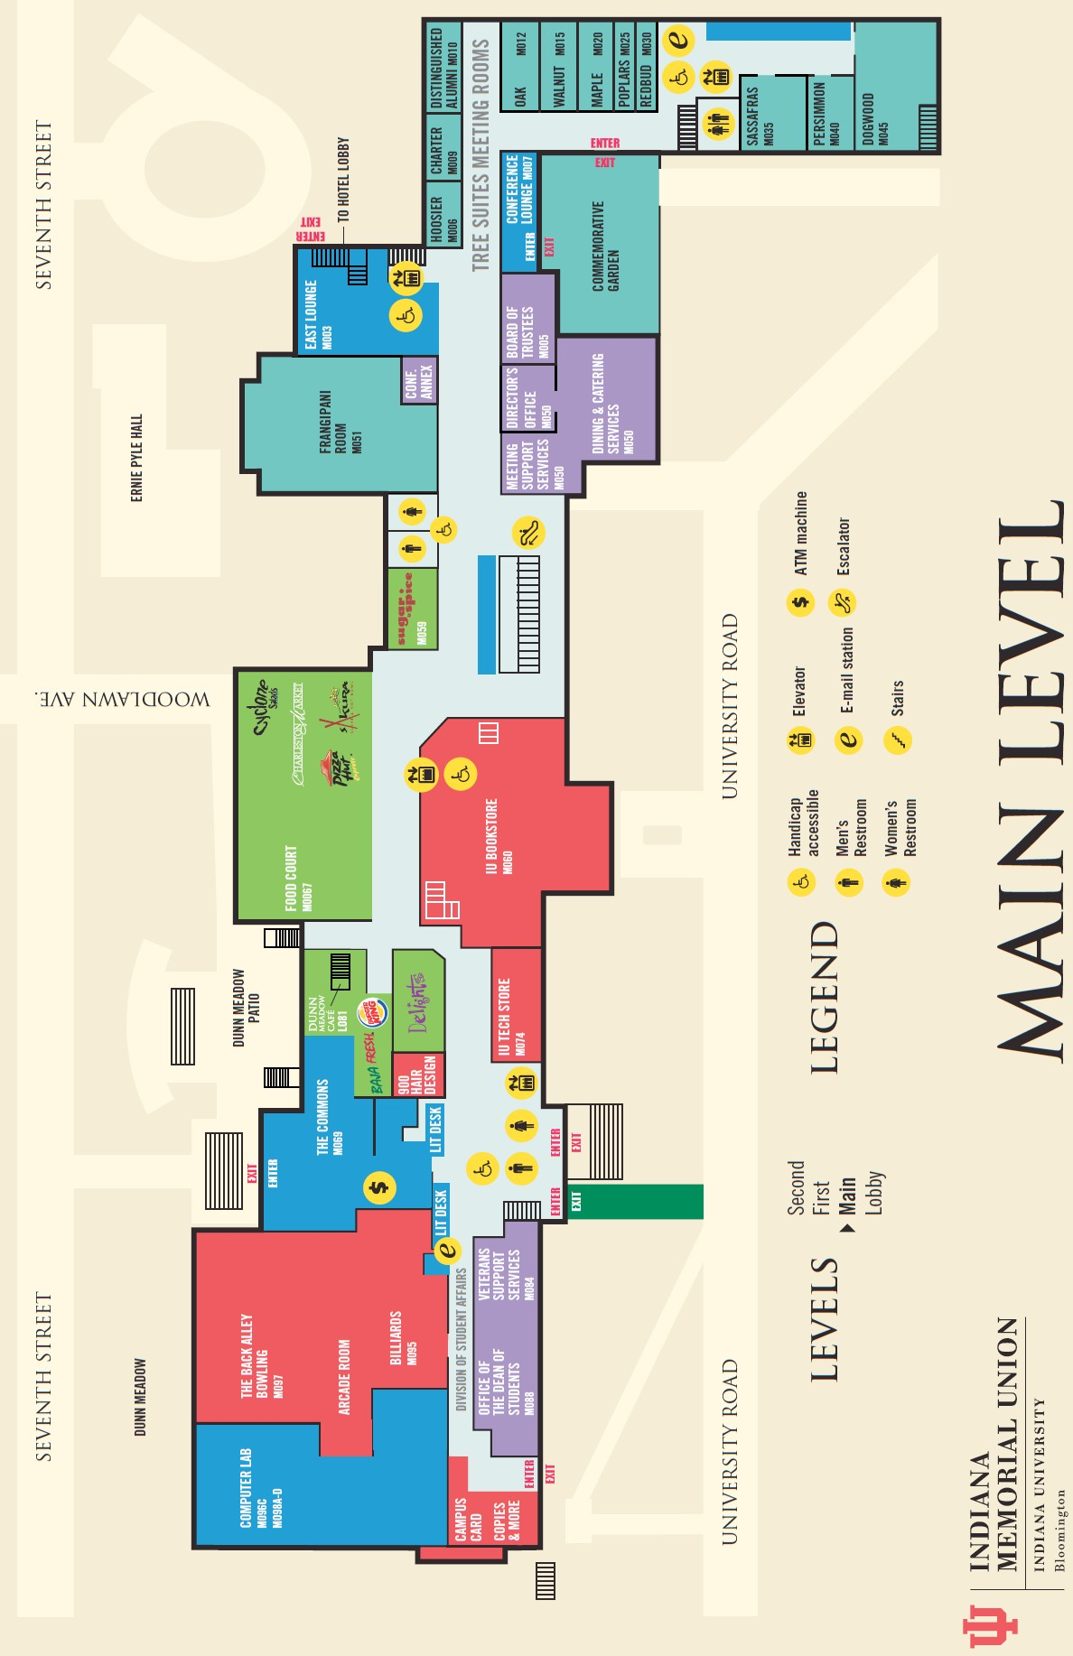

! Conference

! Food court

! To Downtown

NOTES

DIÁLOGOS XII
SPONSORS

Department of Spanish and Portuguese
IU Student Association
Department of American Studies
La Casa: Latino Cultural Center
Cultural Studies Program
Department of English
Institute for European Studies
Renaissance Studies Program
American Studies Program
Department of Linguistics
Center for Theoretical Inquiry in the Humanities

GSAC would like to warmly thank this year’s generous sponsors. The Diálogos Conference would not be possible without your support. ¡Mil gracias! Obrigado!

